**Tensile Strain Capacity as a Strain Profile**

**Test 2**

|  |  |  |  |
| --- | --- | --- | --- |
| **Frame** | **Remote measurement (%)** | **Middle Gauge reading (%)** | **Crack side strain measurement (%)** |
| 600 | 0.573 | 0.48217 | 0.45 |
| 800 | 1.836 | 1.21325 | 0.902 |
| 1000 | 3.08 | 1.98298 | 1.37 |
| 1200 | 4.273 | 2.56218 | 1.72 |
| 1400 | 4.89 | 2.91849 | 2.036 |
| 1500 | 4.91875 | 2.93615 | 2.046 |
| 1600 | 5.983 | **3.7842** | 2.66 |
| 1700 | 7.66 | **5.1919** | 3.85 |

|  |  |  |  |  |  |
| --- | --- | --- | --- | --- | --- |
| **Frame** | **Increase in the remote strain (%)** | **Ratio (left/right)** | **Increase in the gauge reading** | **Ratio (left/right)** | **Increase of the crack side strain (%)** |
| 800 | 1.263 | 1.728 | 0.73108 | 1.617 | 0.452 |
| 1000 | 1.244 | 1.616 | 0.76973 | 1.644 | 0.468 |
| 1200 | 1.193 | 2.06 | 0.5792 | 1.655 | 0.35 |
| 1400 | 0.617 | 1.732 | 0.35631 | 1.128 | 0.316 |
| 1500 | 0.02875 | 1.628 | 0.01766 | 1.766 | 0.01 |
| 1600 | 1.093 |  |  |  | 0.624 |
| 1700 | 1.677 |  |  |  | 1.19 |
|  | Mean | **1.7528** |  | **1.562** |  |

The red numbers in the first table of Test 2 are calculated using the mean values of the ratios in the second table. For example **3.7842** in the first table is calculated as follows:

$$\frac{1}{2}\left(\frac{5.983}{1.7528}+2.66⋅1.562\right)=3.7842$$

|  |  |
| --- | --- |
| Figure 1: Remote measurement | Figure 2: Crack side measurement |

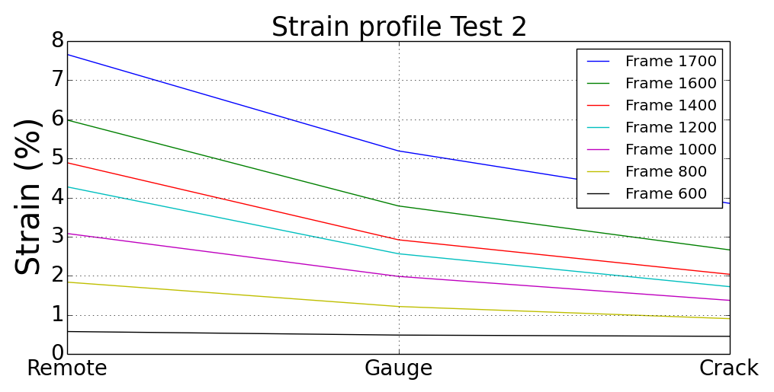

Figure 3: Starting from Frame 800 significant strain values are recorded

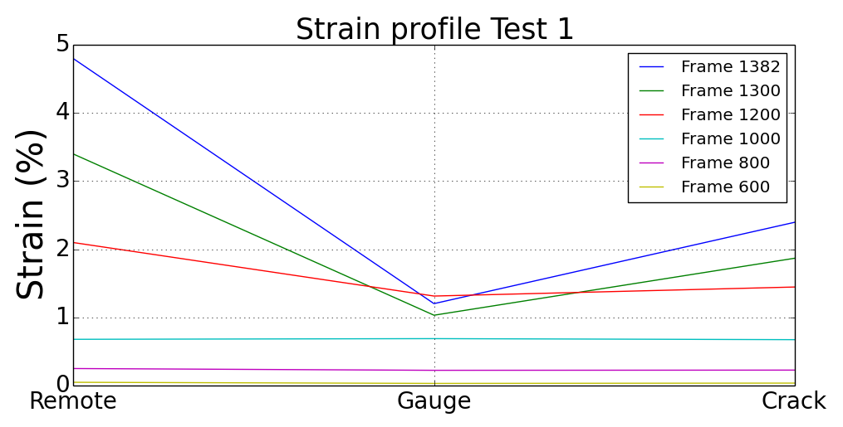

Figure 4: Strain profile of test 1

In Test 1 strain gauge data was available throughout the test. However this time instead of the gauge in the middle, the gauge 2 OD away from the end plate is used in the plots. The reason for this was the erroneous measurements of the middle gauge.

**Test 1**

|  |  |  |  |
| --- | --- | --- | --- |
| **Frame** | **Remote measurement (%)** | **2/3 Gauge reading (%)** | **Crack side strain measurement (%)** |
| 600 | **0.0477** | 0.031152975 | **0.03566** |
| 800 | **0.2496** | 0.223522881 | **0.2265** |
| 1000 | **0.6781** | 0.688172909 | **0.6731** |
| 1200 | **2.099** | 1.313036062 | **1.44583** |
| 1300 | **3.4** | 2.091082 | **1.86875** |
| 1382 | **4.80125** | 2.837624 | **2.39687** |

|  |  |  |  |  |  |
| --- | --- | --- | --- | --- | --- |
| **Frame** | **Increase in the remote strain (%)** | **Ratio (left/right)** | **Increase in the gauge reading** | **Ratio (left/right)** | **Increase of the crack side strain (%)** |
| 800 | 0.2019 | 1.04954 | 0.19237 | 1.008017 | 0.19084 |
| 1000 | 0.4285 | 0.922199 | 0.46465 | 1.040417 | 0.4466 |
| 1200 | 1.4209 | 2.273938 | 0.62486 | 0.808644 | 0.77273 |
| 1300 | 1.301 |  |  |  | 0.42292 |
| 1382 | 1.40125 |  |  |  | 0.52812 |
|  | Mean | **1.415226** |  | **0.952359** |  |